For Text Mining assignment

**ONE:**

**1) Extract tweets for any user (try choosing a user who has more tweets)**

**2) Perform sentimental analysis on the tweets extracted from the above**

Still application is under review which I applied before 1 month.

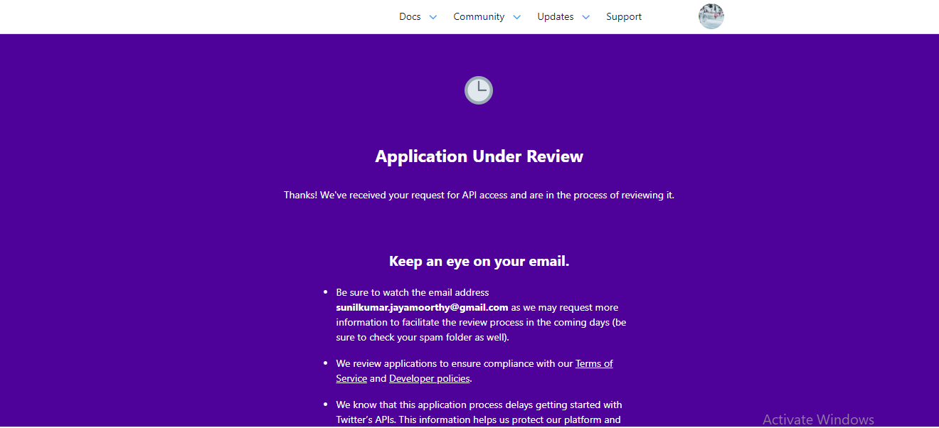

**TWO:**

**1) Extract reviews of any product from ecommerce website like amazon**

**2) Perform emotion mining**

Performing the amazon review for the book

Link: https://www.amazon.in/product-reviews/B0773RQ55P/ref=acr_dp_hist_5?ie=UTF8&filterByStar=five_star&reviewerType=all_reviews#reviews-filter-bar

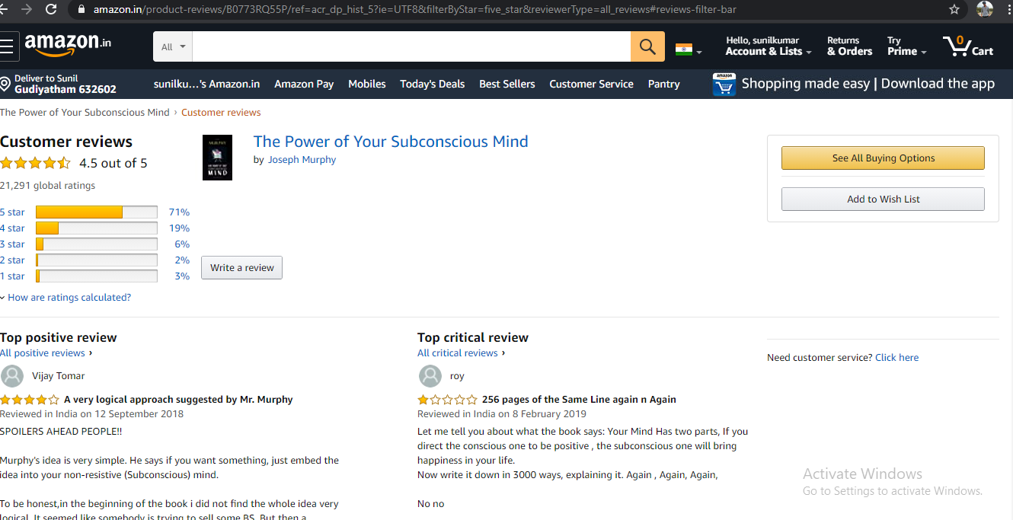

Code:

# -*- coding: utf-8 -*-

"""

Created on Mon Nov 23 09:43:53 2020

@author: sunil

"""

import pandas as pd

import numpy as np

import matplotlib.pyplot as plt

import seaborn as sns

get_ipython().run_line_magic('matplotlib', 'inline')

import re

import time

from datetime import datetime

import matplotlib.dates as mdates

import matplotlib.ticker as ticker

from urllib.request import urlopen

from bs4 import BeautifulSoup as bs

import requests

# In[2]:

wm_title=[]

wm_date = []

wm_content = []

wm_rating = []

for i in range(1,150):

link = "https://www.amazon.in/product-reviews/B0773RQ55P/ref=acr_dp_hist_5?ie=UTF8&filterByStar=five_star&reviewerType=all_reviews#reviews-filter-bar"+str(i)

response = requests.get(link)

soup = bs(response.content,"html.parser")# creating soup object to iterate over the extracted content

# extracting Review Title

title = soup.find_all('a',class_='review-title-content')

review_title = []

for i in range(0,len(title)):

review_title.append(title[i].get_text())

review_title[:] = [titles.lstrip('\n') for titles in review_title]

review_title[:] = [titles.rstrip('\n') for titles in review_title]

wm_title = wm_title + review_title

## Extracting Ratings

rating = soup.find_all('i',class_='review-rating')

review_rating = []

for i in range(2,len(rating)):

review_rating.append(rating[i].get_text())

#review_rating.pop(0)

#review_rating.pop(0)

review_rating[:] = [reviews.rstrip(' out of 5 stars') for reviews in review_rating]

wm_rating = wm_rating + review_rating

#Extracting Content of review

review = soup.find_all("span",{"data-hook":"review-body"})

review_content = []

for i in range(0,len(review)):

review_content.append(review[i].get_text())

review_content[:] = [reviews.lstrip('\n') for reviews in review_content]

review_content[:] = [reviews.rstrip('\n') for reviews in review_content]

wm_content = wm_content + review_content

#Extracting dates of reviews

dates = soup.find_all('span',class_='review-date')

review_dates = []

for i in range(2,len(rating)):

review_dates.append(dates[i].get_text())

review_dates[:] = [reviews.lstrip('Reviewed in India on') for reviews in review_dates]

#review_dates.pop(0)

#review_dates.pop(0)

wm_date = wm_date + review_dates

# In[3]:

print(len(wm_title))

print(len(wm_rating))

print(len(wm_content))

print(len(wm_date))

# In[4]:

df = pd.DataFrame()

df['Title'] = wm_title

df['Ratings'] = wm_rating

df['Comments'] = wm_content

df['Date'] = wm_date

df.head(5)

# In[5]:

df.head(2)

# In[6]:

df['Date'] = pd.to_datetime(df['Date'])

df['Ratings'] = df['Ratings'].astype(float)

df.head(2)

# ## Text Cleaning

#

# 1. lower the text

# 2. tokenize the text (split the text into words) and remove the punctuation

# 3. remove useless words that contain numbers

# 4. remove useless stop words like ‘the’, ‘a’ ,’this’ etc.

# 5. Part-Of-Speech (POS) tagging: assign a tag to every word to define 6. if it corresponds to a noun, a verb etc. using the WordNet lexical database

# 7. lemmatize the text: transform every word into their root form (e.g. rooms -> room, slept -> sleep)

# In[ ]:

df.head(2)

# In[7]:

from nltk.corpus import wordnet

def get_wordnet_pos(pos_tag):

if pos_tag.startswith('J'):

return wordnet.ADJ

elif pos_tag.startswith('V'):

return wordnet.VERB

elif pos_tag.startswith('N'):

return wordnet.NOUN

elif pos_tag.startswith('R'):

return wordnet.ADV

else:

return wordnet.NOUN

import string

import nltk

from nltk import pos_tag

from nltk.corpus import stopwords

from nltk.tokenize import WhitespaceTokenizer

from nltk.stem import WordNetLemmatizer

nltk.download('stopwords')

nltk.download('averaged_perceptron_tagger')

nltk.download('wordnet')

nltk.download('vader_lexicon')

# In[8]:

def clean_text(text):

# lower text

text = text.lower()

# tokenize text and remove puncutation

text = [word.strip(string.punctuation) for word in text.split(" ")]

# remove words that contain numbers

text = [word for word in text if not any(c.isdigit() for c in word)]

# remove stop words

stop = stopwords.words('english')

text = [x for x in text if x not in stop]

# remove empty tokens

text = [t for t in text if len(t) > 0]

# pos tag text

pos_tags = pos_tag(text)

# lemmatize text

text = [WordNetLemmatizer().lemmatize(t[0], get_wordnet_pos(t[1])) for t in pos_tags]

# remove words with only one letter

text = [t for t in text if len(t) > 1]

# join all

text = " ".join(text)

return(text)

# In[9]:

# clean text data

df["Comments"] = df["Comments"].apply(lambda x: clean_text(x))

# In[10]:

df['Title'] = df['Title'].astype(str)

df['Title'] = df['Title'].apply(lambda x: clean_text(x))

# In[14]:

df.head(5)

# ## Feature Engineering

# In[23]:

# add sentiment anaylsis columns

from nltk.sentiment.vader import SentimentIntensityAnalyzer

sid = SentimentIntensityAnalyzer()

df["sentiments"] = df["Comments"].apply(lambda x: sid.polarity_scores(x))

df = pd.concat([df.drop(['sentiments'], axis=1), df['sentiments'].apply(pd.Series)], axis=1)

'''

sid = SentimentIntensityAnalyzer()

df["sentiments_title"] = df["Title"].apply(lambda x: sid.polarity_scores(x))

df = pd.concat([df.drop(['sentiments_title'], axis=1), df['sentiments_title'].apply(pd.Series)], axis=1)

'''

df

# In[12]:

# add number of characters column

df["nb_chars"] = df["Comments"].apply(lambda x: len(x))

# add number of words column

df["nb_words"] = df["Comments"].apply(lambda x: len(x.split(" ")))

''''

# add number of characters column

df["nb_chars_title"] = df["Title"].apply(lambda x: len(x))

# add number of words column

df["nb_words_title"] = df["Title"].apply(lambda x: len(x.split(" ")))

'''

# In[13]:

# create doc2vec vector columns

from gensim.test.utils import common_texts

from gensim.models.doc2vec import Doc2Vec, TaggedDocument

documents = [TaggedDocument(doc, [i]) for i, doc in enumerate(df["Comments"].apply(lambda x: x.split(" ")))]

# train a Doc2Vec model with our text data

model = Doc2Vec(documents, vector_size=5, window=2, min_count=1, workers=4)

# transform each Comment into a vector data

doc2vec_df = df["Comments"].apply(lambda x: model.infer_vector(x.split(" "))).apply(pd.Series)

doc2vec_df.columns = ["doc2vec_vector_" + str(x) for x in doc2vec_df.columns]

df = pd.concat([df, doc2vec_df], axis=1)

'''

# transform each Title into a vector data

doc2vec_df_title = df["Title"].apply(lambda x: model.infer_vector(x.split(" "))).apply(pd.Series)

doc2vec_df_title.columns = ["doc2vec_vector_" + str(x) for x in doc2vec_df.columns]

df = pd.concat([df, doc2vec_df_title], axis=1)

'''

# In[14]:

# add tf-idfs columns

from sklearn.feature_extraction.text import TfidfVectorizer

tfidf = TfidfVectorizer(min_df = 10)

tfidf_result = tfidf.fit_transform(df["Comments"]).toarray()

tfidf_df = pd.DataFrame(tfidf_result, columns = tfidf.get_feature_names())

tfidf_df.columns = ["word_" + str(x) for x in tfidf_df.columns]

tfidf_df.index = df.index

df = pd.concat([df, tfidf_df], axis=1)

'''

##TF-IDF for Titles

tfidf = TfidfVectorizer(min_df = 10)

tfidf_result = tfidf.fit_transform(df["Title"]).toarray()

tfidf_df_title = pd.DataFrame(tfidf_result, columns = tfidf.get_feature_names())

tfidf_df_title.columns = ["word_" + str(x) for x in tfidf_df_title.columns]

tfidf_df_title.index = df.index

df = pd.concat([df, tfidf_df_title], axis=1)

'''

# In[15]:

from wordcloud import WordCloud

import matplotlib.pyplot as plt

def show_wordcloud(data, title = None):

wordcloud = WordCloud(

background_color = 'white',

max_words = 200,

max_font_size = 40,

scale = 3,

random_state = 42

).generate(str(data))

fig = plt.figure(1, figsize = (20, 20))

plt.axis('off')

if title:

fig.suptitle(title, fontsize = 20)

fig.subplots_adjust(top = 2.3)

plt.imshow(wordcloud)

plt.show()

# print wordcloud

show_wordcloud(df["Comments"])

# In[16]:

# print wordcloud

show_wordcloud(df["Title"])

# In[21]:

df.head(2)

# In[17]:

# highest positive sentiment reviews (with more than 5 words)

df[df["nb_words"] >= 5].sort_values("pos", ascending = False)[["Comments", "pos"]].head(10)

# In[18]:

# lowest negative sentiment reviews (with more than 5 words)

df[df["nb_words"] >= 5].sort_values("neg", ascending = False)[["Comments", "neg"]].head(10)

# In[19]:

df['Month'] = df['Date'].dt.month

df['Year'] = df['Date'].dt.year

df.head(2)

# In[20]:

df_recent = df[(df['Year']== 2020) & (df['Month'] != 8)]

df_recent.head(2)

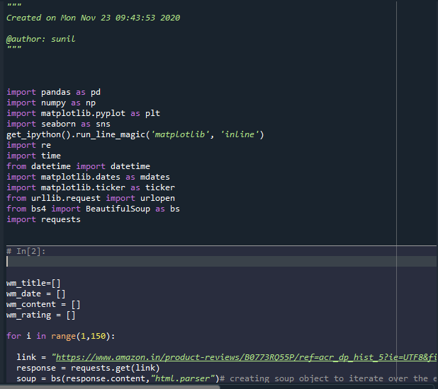

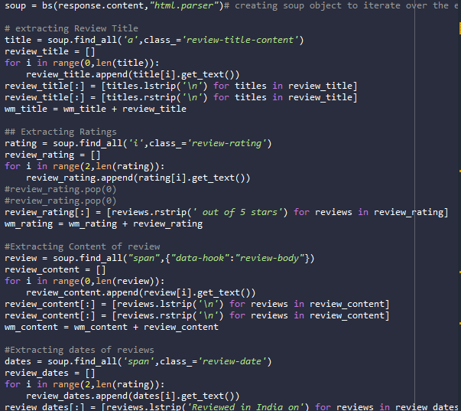

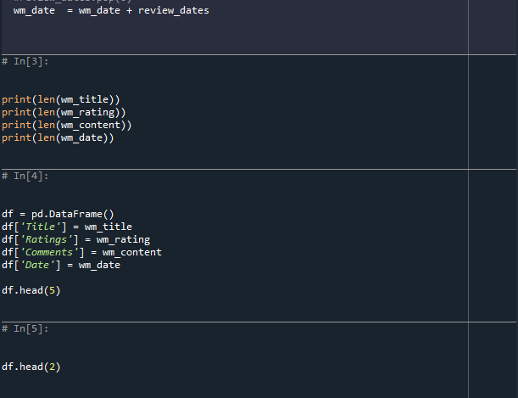

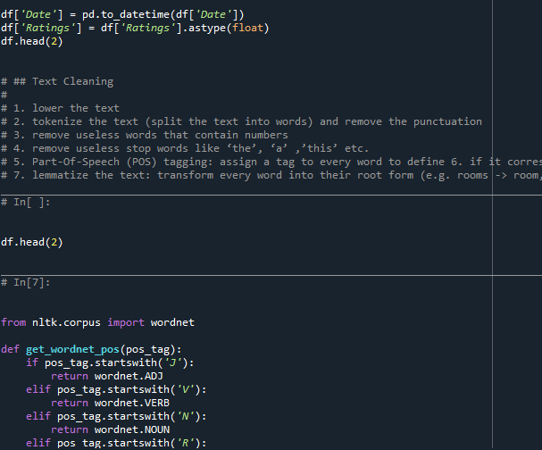

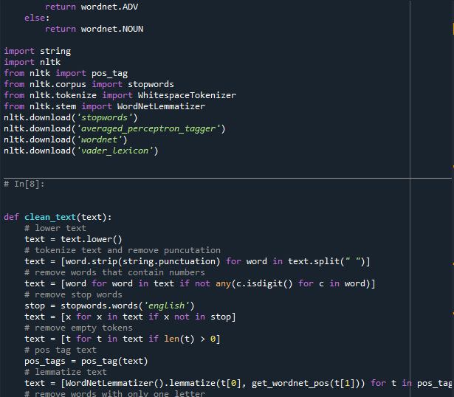

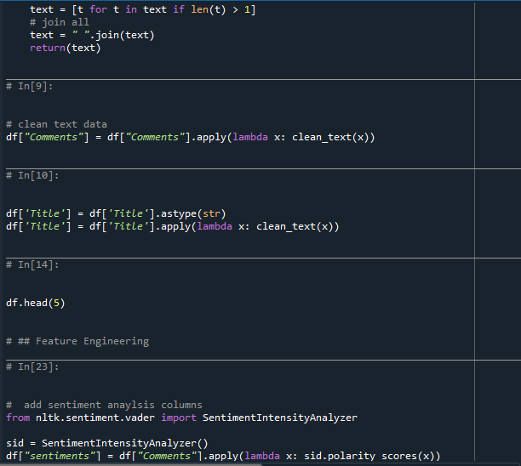

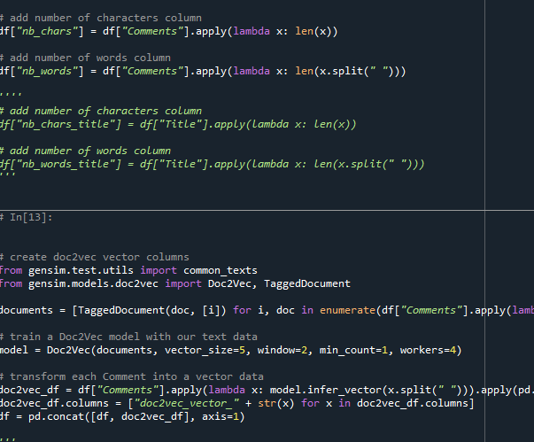

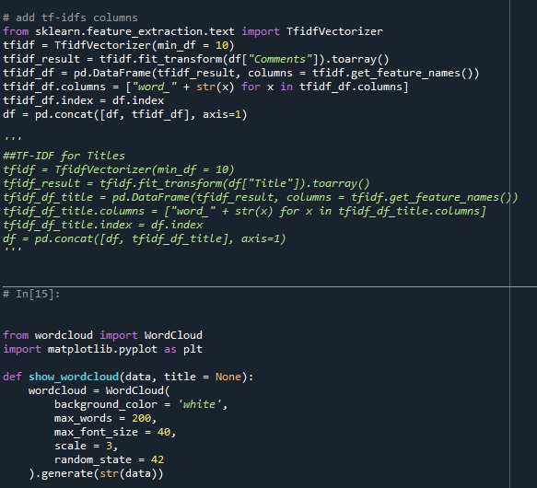

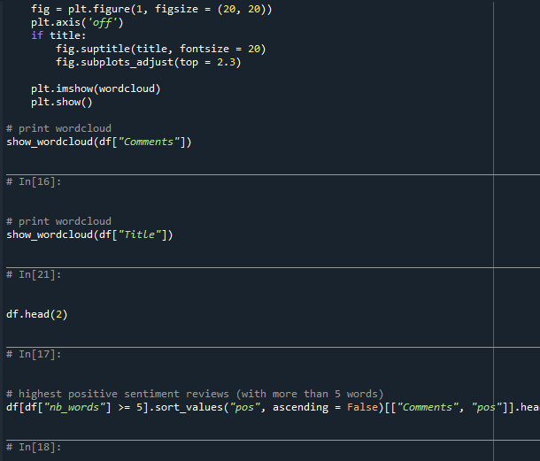

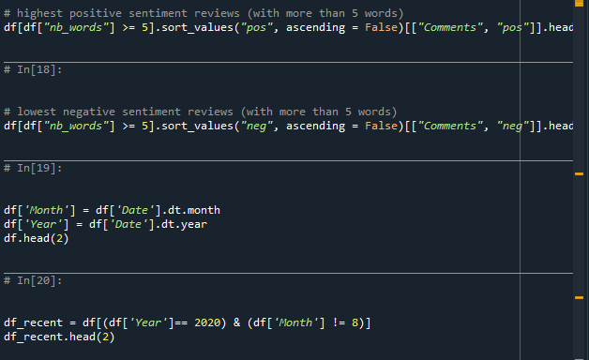

Output:

